Reception | Outside Inside Autumn 1 |  |  |  |  | Knowing Yourself Autumn 2
Writing Root Text | 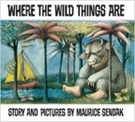  Where the Wild Things Are  Maurice Sendak |  |  | 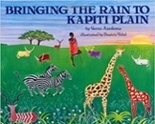  Bringing the Rain to Kapiti Plain  Verma Aardema |  | 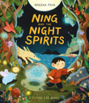  Ning and the Night Spirits  by Adriena Fong |  | 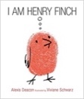  OR I am Henry Finch  Alexis Deacon
Theme/Term | Talents & powers Spring 1 |  |  |  |  | Sowing a seed Spring 2
Writing Root Text | 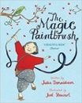  The Magic Paintbrush  Julia Donaldson and Joel Stewart |  |  | 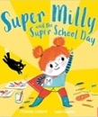  OR Super Milly and the Super School Day  Stephanie Clarkson |  | 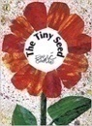  The Tiny Seed  Eric Carle |  | 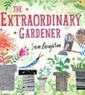  OR The Extraordinary Gardener  Sam Boughton
Theme/Term | Celebrating self Summer 1 |  |  |  |  | Family & friends Summer 2
Writing Root Text | 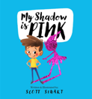  OR My Shadow is Pink  Scott Stuart |  |  | 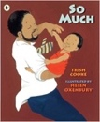  So Much  Trish Cooke and Helen Oxenbury |  | 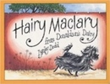  Hairy Maclary from Donaldson’s Dairy  Lynley Dodd |  | 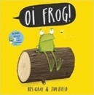  Oi! Frog  Kes Gray and Jim Field
Year 1 | Journeys & exploration Autumn 1 |  |  |  |  | Heroes & villains Autumn 2
Writing Root/  Spelling Seed Text | 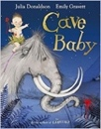  Cave Baby  Julia Donaldson and Emily Gravett |  |   Astro Girl  Ken Wilson-Max |  |  | 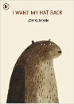  I Want My Hat Back  Jon Klassen |  | 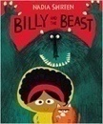  Billy and the Beast  Nadia Shireen
Theme/Term | Similarities & differences Spring 1 |  |  |  |  | Nature & environment Spring 2
Writing Root/  Spelling Seed Text | 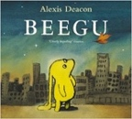  Beegu  Alexis Deacon |  |  | 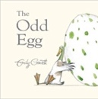  The Odd Egg  Emily Gravett |  | 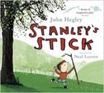  Stanley’s Stick  John Hegley and Neal Layton |  | 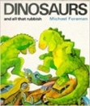  Dinosaurs and all that Rubbish  Michael Foreman
Theme/Term | Friendship & kindness Summer 1 |  |  |  |  | Imagination & creativity Summer 2
Writing Root/  Spelling Seed Text | 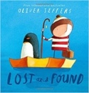  Lost and Found  Oliver Jeffers |  |  | 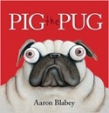  OR Pig the Pug  Aaron Blabey |  | 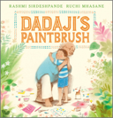  Dadaji’s Paintbrush  Rashmi Sirdeshpande |  | 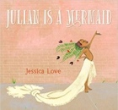  Julian is a Mermaid  Jessica Love
Year 2 | Creation and conservation Autumn 1 |  |  |  |  | Creation & conservation Autumn 2
Writing Root/  Spelling Seed Text | 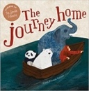  The Journey Home  Frann Preston-Gannon |  |  |  |  | 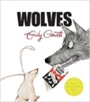  Wolves  Emily Gravett |  | 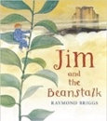  OR Jim and the Beanstalk  Raymond Briggs
Theme/Term | Bravery vs. fear Spring 1 |  |  |  |  | Change & relationships Spring 2
Writing Root/  Spelling Seed Text | 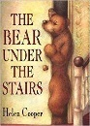  The Bear Under the Stairs  Helen Cooper |  |  | 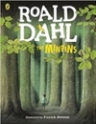  The Minpins  Roald Dahl |  | 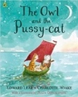  The Owl and the Pussy-cat  Edward Lear |  | 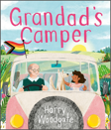  Grandad’s Camper  Harry Woodgate
Theme/Term | Fictional Worlds & fantasy Summer 1 |  |  |  |  | Urban metropolis Summer 2
Writing Root/  Spelling Seed Text | 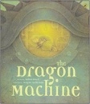  The Dragon Machine  Helen Ward |  |  | 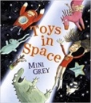  Or Toys in Space  Mini Grey |  | 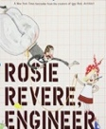  Rosie Revere, Engineer  Andrea Beaty |  | 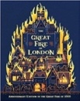  OR The Great Fire of London  Emma Adams
Year 3 | Magic & wonder Autumn 1 |  |  |  |  | Dreams & curiosity Autumn 2
Writing Root/  Spelling Seed Text | 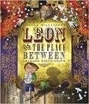  Leon and the Place Between  Angela McAllister |  |  | 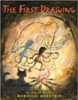  OR The First Drawing  Mordicai Gerstein |  | 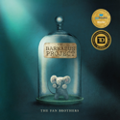  OR The Barnabus Project  The Fan Brothers |  | 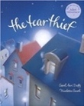  The Tear Thief  Carol Ann Duffy
Theme/Term | Hope & healing Spring 1 |  |  |  |  | Overcoming adversity Spring 2  Cloud Tea Monkeys  Mal Peet & Elspeth Graham
Writing Root/  Spelling Seed Text | 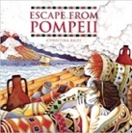  Escape from Pompeii  Christina Balit |  |  | 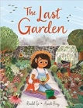  OR The Last Garden  Rachel Ip |  | 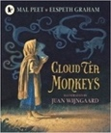 |  | 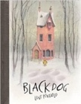  OR Black Dog  Levi Pinfold
Theme/Term | From mystery to discovery Summer 1 |  |  |  |  | Confidence & caution Summer 2
Writing Root/  Spelling Seed Text | 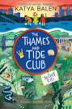  The Thames and Tide Club  Katya Balen |  |  | 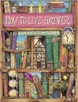  How to Live Forever  Colin Thompson |  | 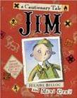  Jim, A Cautionary Tale  Hilaire Belloc |  | 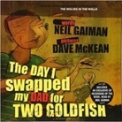  OR The Day I Swapped my Dad for Two Goldfish  Neil Gaiman
Year 4 | Finding Freedom Autumn 1 |  |  |  |  | Invention & innovation Autumn 2
Writing Root/  Spelling Seed Text | 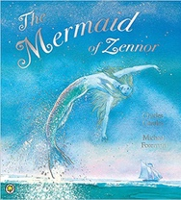  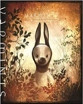  Varmints  Helen Ward |  |  | 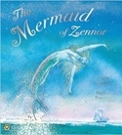  OR The Mermaid of Zennor  Charles Causley |  | 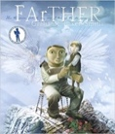  FArTHER  Grahame Baker Smith |  |  | 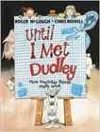  Until I Met Dudley  Roger McGough and Chris Riddell
Theme/Term | Darkness & light Spring 1 |  |  |  |  | Taking courage Spring 2
Writing Root/  Spelling Seed Text | 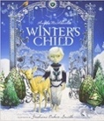  OR Winter’s Child  Angela McAllister |  | 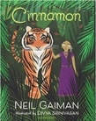  Cinnamon  Neil Gaiman |  |  | 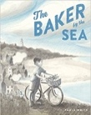  The Baker by the Sea  Paula White |  | 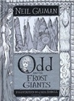  Odd and the Frost Giants  Neil Gaiman
Theme/Term | Unearthing Civilisations Summer 1 |  |  |  |  | A window to the world Summer 2
Writing Root/  Spelling Seed Text | 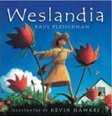  Weslandia  Paul Fleischman |  | 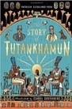  The Story of Tutankhamun  Patricia Cleveland-Peck |  |  | 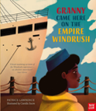  OR Granny Came Here on the Empire Windrush  Patrice Lawrence |  | 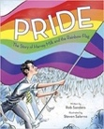  OR Pride: The Story of Harvey Milk and the Rainbow Flag  Rob Sanders
Year 5 |  | Ambition & desire Autumn 1 |  |  |  |  | Power vs. principles Autumn 2
Writing Root /  Spelling Seed Text |  | 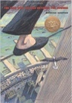  The Man Who Walked Between the Towers  Mordicai Gerstein |  |  |   Robot Girl  Malorie Blackman |  | 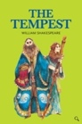  The Tempest  William Shakespeare |  |  | 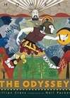  The Odyssey  Gillian Cross
Theme/Term |  | Belonging & equality Spring 1 |  |  |  |  | Legends & folklore Spring 2
Writing Root /  Spelling Seed Text |  | 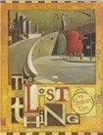  The Lost Thing  Shaun Tan |  |  | 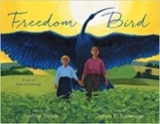  OR Freedom Bird  Jerdine Nolen |  | 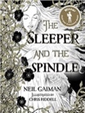  The Sleeper and the Spindle  Neil Gaiman and Chris Riddell |  |  | 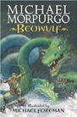  Beowulf  Michael Morpurgo
Theme/Term |  | Lessons from history Summer 1 |  |  |  |  | Mystery & truth Summer 2
Writing Root /  Spelling Seed Text |  | 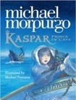  Kaspar, Prince of Cats  Michael Morpurgo |  |  | 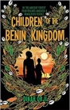  OR Children of the Benin Kingdom  Dina Orji |  | 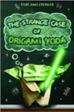  OR Origami Yoda  Tom Angleberger |  |  | 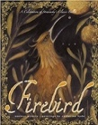  OR Firebird  Saviour Pirotta and Catherine Hyde
Year 6 |  | Journeys and migration Autumn 1 |  |  |  |  | Evolution & inheritance Autumn 2
Writing Root /  Spelling Seed Text |  | 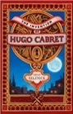  The Invention of Hugo Cabret  Brian Selznick |  |  | 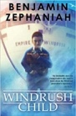  Windrush Child  Benjamin Zephaniah |  | 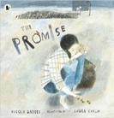  The Promise  Nicola Davies |  |  | 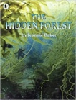  The I can write  commands  I can use  capital  letters and  full stops Forest  Jeannie Baker
Theme/Term |  | Protest & activism Spring 1 |  |  |  |  | Utopia vs. dystopia Spring 2
Writing Root /  Spelling Seed Text |  | 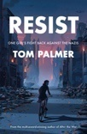  Resist  Tom Palmer |  |  | 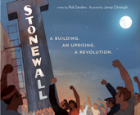  Stonewall  Rob Sanders & Jamey Christoph |  | 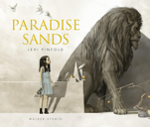  Paradise Sands  Levi Pinfold |  |  | 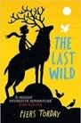  The Last Wild  Piers Torday
Theme/Term |  | Fate vs. free will Summer 1 |  |  |  |  | Crossing borders Summer 2
Writing Root /  Spelling Seed Text |  | 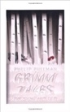  Grimm Tales for Young and Old Phillip Pullman |  |  | 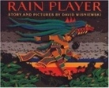  Rain Player  David Wisniewski |  | 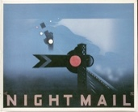  Night Mail  W H Auden |  |  | 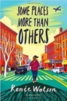  Some Places More Than Others  Renee Watson

