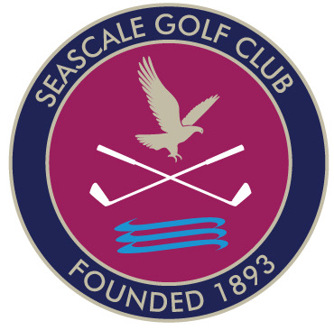
SEASCALE GOLF CLUB
Junior coaching
contact
Bev New
PGA Advanced Professional
bev.new@aol.co.uk
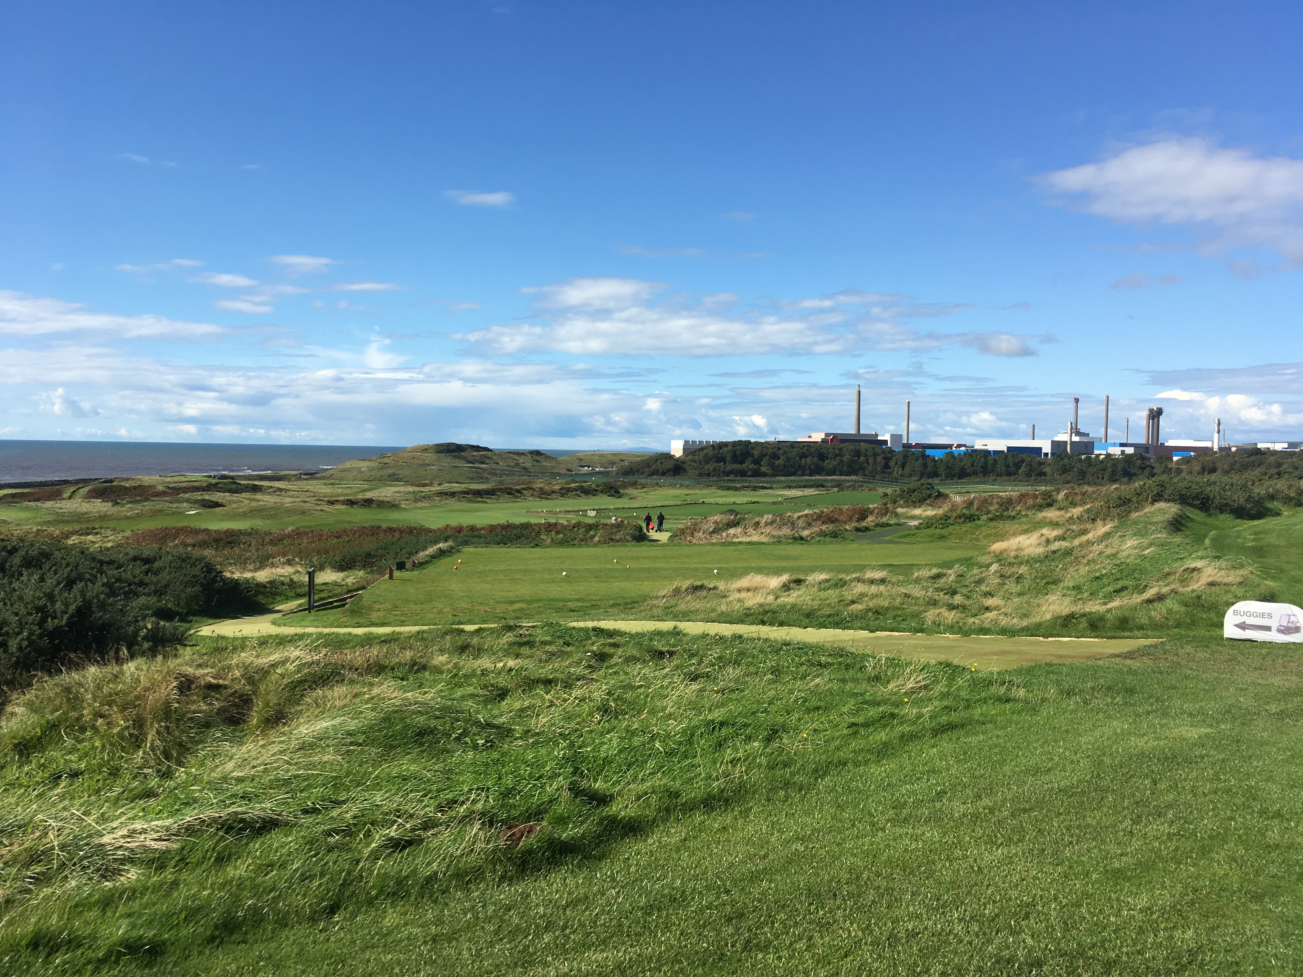


07549701243
Come along and have some fun - equipment provided
Coaching available every other Saturday
Affordable memberships available
contact Adam at Seascale Golf Club

01946728202

