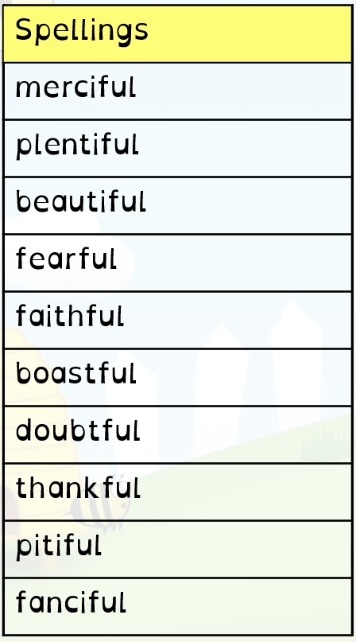
Year 6 Homework 10/2/20 Hand in Monday 24/2/20
Maths
- Page 26 (Fractions, decimals and percentages)
- 40 minutes minimum on Mathletics (I will be checking!)

English
- Page 17 in textbook (prepositions)
- Read at least 10 times and record in your diary. Get an adult to sign it before Monday
- Spellings. Practise these spellings for a test on Friday 14th Feb. Use the space on this page to revise and test yourself using a method you find helpful.
Topic
Design an A3 poster about a volcano of your choice. This can have lift up flaps and other devices to add interest. Hand in Monday 24th February

Year 6 Homework 10/2/20 Hand in Monday 24/2/20
Maths
- Page 26 (Fractions, decimals and percentages)
- 40 minutes minimum on Mathletics (I will be checking!)

English
- Page 17 in textbook (prepositions)
- Read at least 10 times and record in your diary. Get an adult to sign it before Monday
- Spellings. Practise these spellings for a test on Friday 14th Feb. Use the space on this page to revise and test yourself using a method you find helpful.
Topic
Design an A3 poster about a volcano of your choice. This can have lift up flaps and other devices to add interest. Hand in Monday 24th February

