Year 6 Homework 27/1/2020 Hand in Monday 3/2/2020
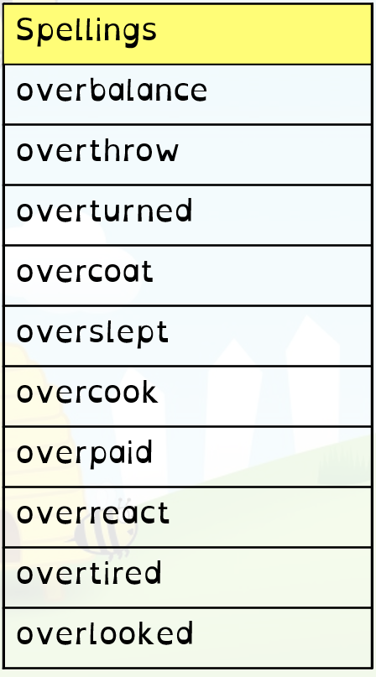
Maths
- Page 15 in textbook (problems)
- 20 minutes minimum on Mathletics (I will be checking!)
English
- Page 16 in textbook (subordinating conjunctions)
- Read at least 5 times and record in your diary. Get an adult to sign it before Monday. Please don’t skimp – our reading fluency is very important!
- Spellings. Practise these spellings for a test on Friday. Use the space on this page to revise and test yourself using a method you find helpful.

Year 6 Homework 27/1/2020 Hand in Monday 3/2/2020
Maths
- Page 15 in textbook (problems)
- 20 minutes minimum on Mathletics (I will be checking!)
English
- Page 16 in textbook (subordinating conjunctions)
- Read at least 5 times and record in your diary. Get an adult to sign it before Monday. Please don’t skimp – our reading fluency is very important!
- Spellings. Practise these spellings for a test on Friday. Use the space on this page to revise and test yourself using a method you find helpful.

