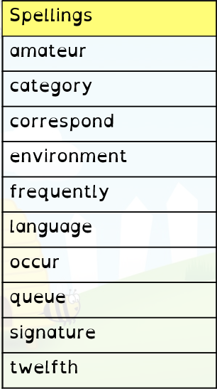
Year 6 Homework 28/10/19 Hand in Monday 4/11/19
Maths
- Page 8 in textbook (written +/-)
- 20 minutes minimum on Mathletics (I will be checking!)
English
- Page 9 in textbook (writing about the future)
- Read at least 5 times and record in your diary. Get an adult to sign it before Monday
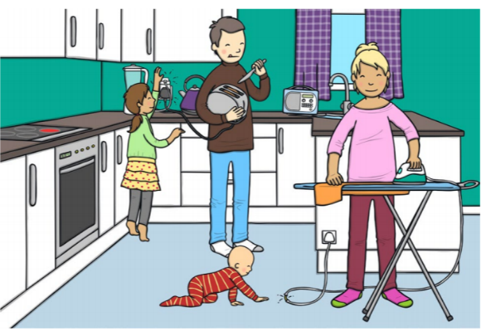
- Spellings. Practise these spellings for a test on Friday. Use the space on this page to revise and test yourself using a method you find helpful.
Topic
Draw your own ‘electrical hazards spotting’ picture. It can be based in the kitchen or another room of your choice. Try and include at least 5 hazards for people to spot. Here is an example.

Year 6 Homework 28/10/19 Hand in Monday 4/11/19
Maths
- Page 8 in textbook (written +/-)
- 20 minutes minimum on Mathletics (I will be checking!)
English
- Page 9 in textbook (writing about the future)
- Read at least 5 times and record in your diary. Get an adult to sign it before Monday
- Spellings. Practise these spellings for a test on Friday. Use the space on this page to revise and test yourself using a method you find helpful.
Topic
Draw your own ‘electrical hazards spotting’ picture. It can be based in the kitchen or another room of your choice. Try and include at least 5 hazards for people to spot. Here is an example.

