Year 6 Homework 4/3/19 Hand in Monday 11/3/19
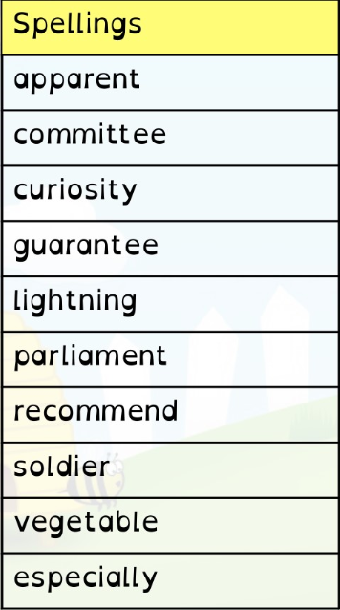
Maths
- Page 32 in textbook (algebra)
- 20 minutes minimum on Mathletics (I will be checking!)

English
- Page 33 in textbook (semi-colons)
- Read at least 5 times and record in your diary. Get an adult to sign it before Monday
- Spellings. Practise these spellings for a test on Friday 8th March. Use the space on this page to revise and test yourself using a method you find helpful.
- Spelling Shed activity before Monday 11th March

Year 6 Homework 4/3/19 Hand in Monday 11/3/19
Maths
- Page 32 in textbook (algebra)
- 20 minutes minimum on Mathletics (I will be checking!)

English
- Page 33 in textbook (semi-colons)
- Read at least 5 times and record in your diary. Get an adult to sign it before Monday
- Spellings. Practise these spellings for a test on Friday 8th March. Use the space on this page to revise and test yourself using a method you find helpful.
- Spelling Shed activity before Monday 11th March

