Year 6 Homework 14/1/19 Hand in Monday 21/1/19
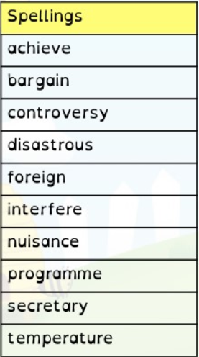
Maths
- Page 25 in textbook (rounding decimals)
- 20 minutes minimum on Mathletics (I will be checking!)
English
- Page 25 in textbook (active/passive voice)
- Read at least 5 times and record in your diary. Get an adult to sign it before Monday
- Spellings. Practise these spellings for a test on Friday. Use the space on this page to revise and test yourself using a method you find helpful.
- Spelling Shed activity before Monday
Science
Look for electrical hazards in your home. Explain to your parents why you think they are a hazard!

Year 6 Homework 14/1/19 Hand in Monday 21/1/19
Maths
- Page 25 in textbook (rounding decimals)
- 20 minutes minimum on Mathletics (I will be checking!)
English
- Page 25 in textbook (active/passive voice)
- Read at least 5 times and record in your diary. Get an adult to sign it before Monday
- Spellings. Practise these spellings for a test on Friday. Use the space on this page to revise and test yourself using a method you find helpful.
- Spelling Shed activity before Monday
Science
Look for electrical hazards in your home. Explain to your parents why you think they are a hazard!

