Year 6 Homework 4/2/19 Hand in Monday 11-/2/19
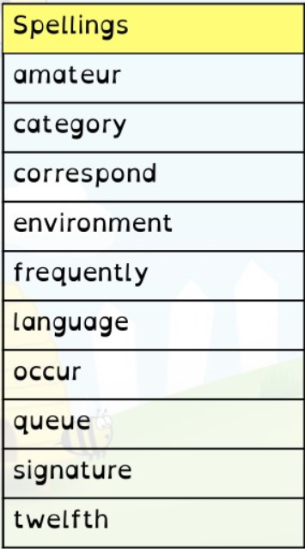
Maths
- Page 26 in textbook (converting fractions)
- 20 minutes minimum on Mathletics (I will be checking!)

English
- Page 17 in textbook (prepositions)
- Read at least 5 times and record in your diary. Get an adult to sign it before Monday
- Spellings. Practise these spellings for a test on Friday. Use the space on this page to revise and test yourself using a method you find helpful.
- Spelling Shed activity before Monday
- Determiner sheet in pink book

Year 6 Homework 4/2/19 Hand in Monday 11-/2/19
Maths
- Page 26 in textbook (converting fractions)
- 20 minutes minimum on Mathletics (I will be checking!)

English
- Page 17 in textbook (prepositions)
- Read at least 5 times and record in your diary. Get an adult to sign it before Monday
- Spellings. Practise these spellings for a test on Friday. Use the space on this page to revise and test yourself using a method you find helpful.
- Spelling Shed activity before Monday
- Determiner sheet in pink book

