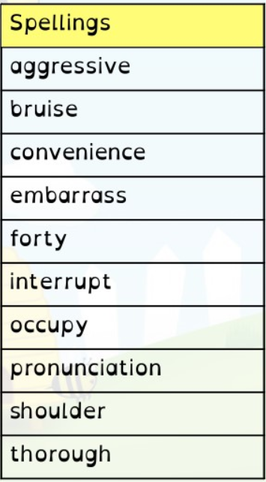
Year 6 Homework 28/1/19 Hand in Monday 4/2/19
Maths
- Page 24 in textbook (division)
- 20 minutes minimum on Mathletics (I will be checking!)
- Sheet – area and perimeter. Please show your working out in your pink book
English
- Page 28 in textbook (subjunctive form)
- Read at least 5 times and record in your diary. Get an adult to sign it before Monday
- Spellings. Practise these spellings for a test on Friday. Use the space on this page to revise and test yourself using a method you find helpful.
- Spelling Shed activity before Monday

Year 6 Homework 28/1/19 Hand in Monday 4/2/19
Maths
- Page 24 in textbook (division)
- 20 minutes minimum on Mathletics (I will be checking!)
- Sheet – area and perimeter. Please show your working out in your pink book
English
- Page 28 in textbook (subjunctive form)
- Read at least 5 times and record in your diary. Get an adult to sign it before Monday
- Spellings. Practise these spellings for a test on Friday. Use the space on this page to revise and test yourself using a method you find helpful.
- Spelling Shed activity before Monday

