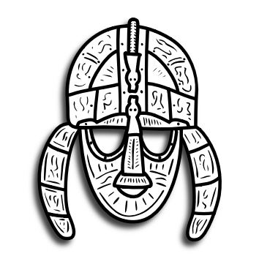
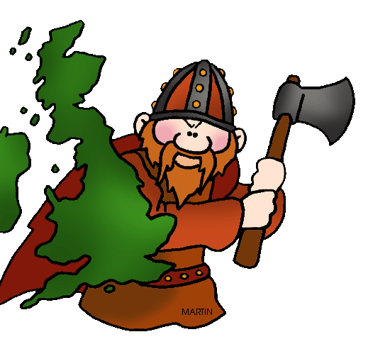
Autumn 1 2018 Year 4 Newsletter
Maths: We will be looking at place value including looking at the value of each digit in a four digit number, roman numerals and solving word problems. We will also be looking at addition and subtraction, looking at different methods for calculation.

R.E: This half term we will be looking at Buddhism. We will also be exploring what makes us happy.
French: The children will be learning to talk about
Animals.
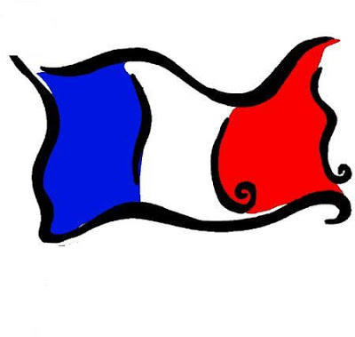

Topic (History): We will be learning all about the Anglo-Saxons this half term linking it to our English and D&T work too. We will cover: when they arrived in Britain, their settlements and the conversion to Christianity. We will also be looking at the significance of Sutton Hoo.
D&T: We will be designing and constructing our own Anglo-Saxon structure.
Computing: Computing—we will be writing a wiki about our topic using Purple Mash.
P.E: Our sports coaching will begin again this half term with Andrew from Reds in the Community. The children will be looking at game play and learning how to play hockey. The children will also be attending weekly swimming sessions on a Friday.
Science: Out topic is Living things. The children will be looking at classifying living things including plants and animals. They will also be looking at vertebrates and invertebrates and the different habitats of animals.
English: We will be studying stories with historical settings, looking at the Anglo Saxon story of Beowulf. We will be looking at writing an informal letter in addition to lots of spelling punctuation and grammar work. This will include: verb tenses, determiners and using conjunctions and prepositions to improve sentences.

