Autumn 2 2018 Year 4
R.E: This half term we will be looking at Christianity. We will be learning all about Christmas and how Christians celebrate it.
French: The children will be learning to talk about
Animals.
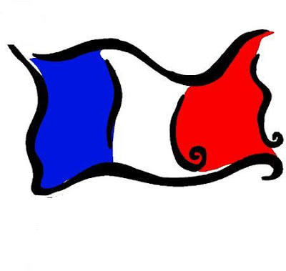

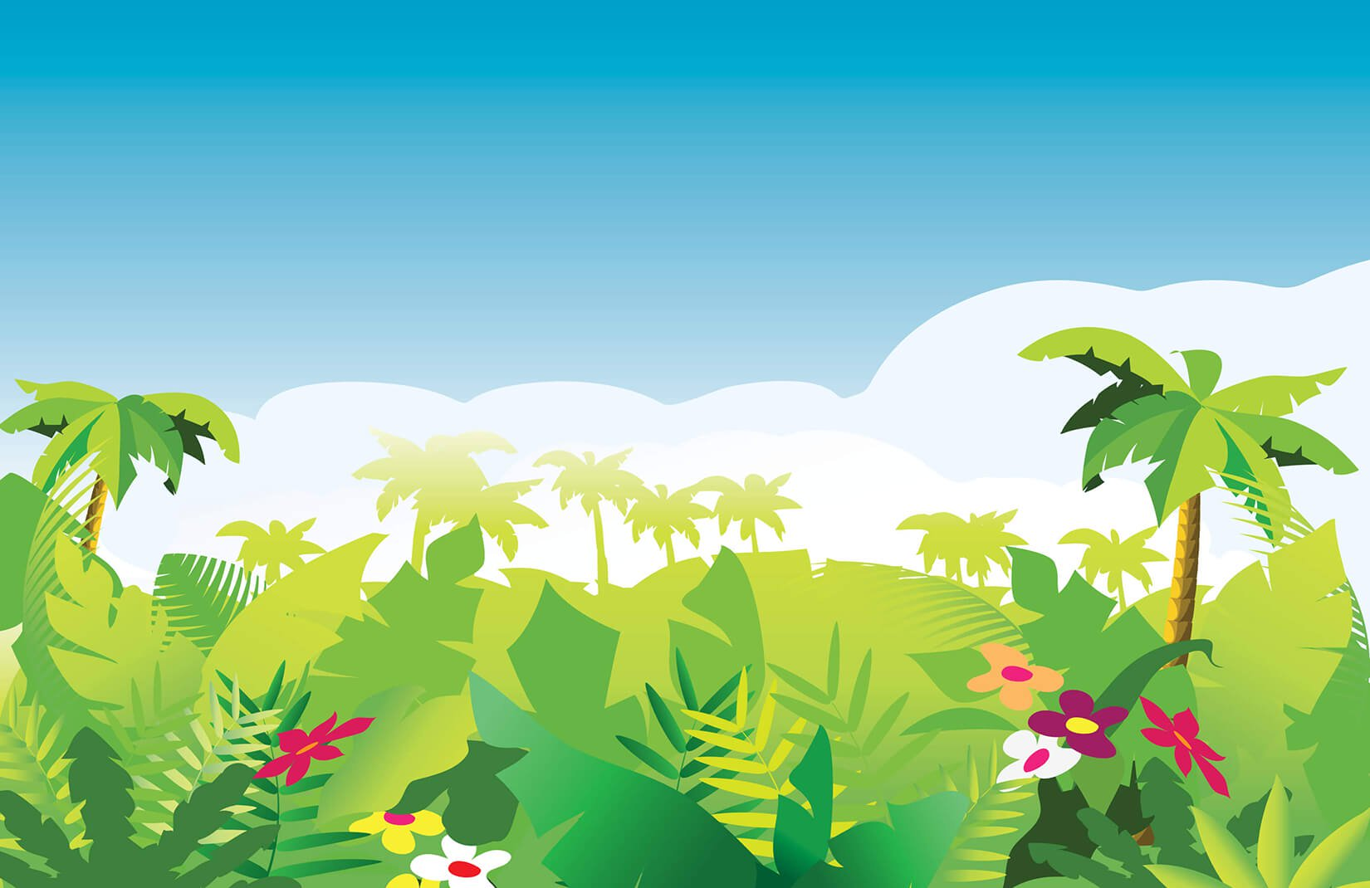
Newsletter

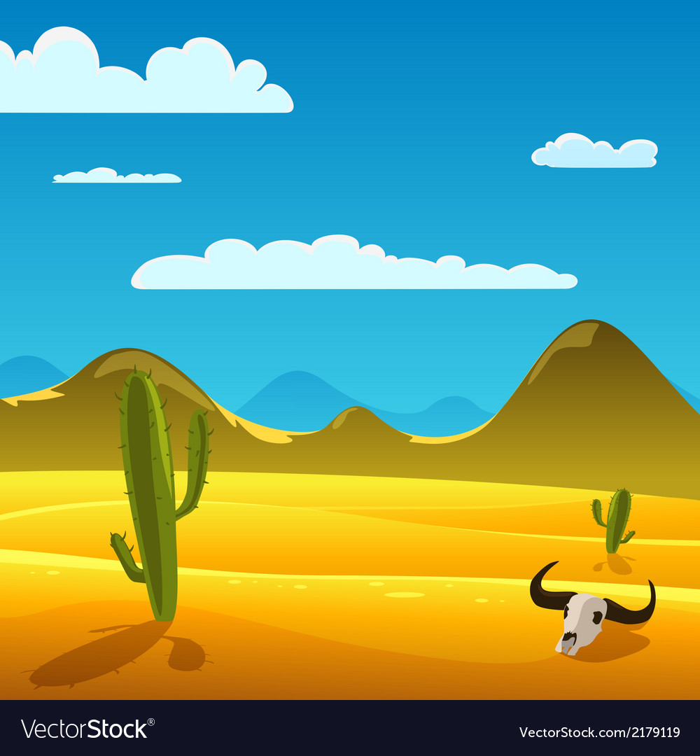
Art: We will be looking at printing this half term including African Prints. This will link with both our Geography and our English work.
Computing: Computing—we will be continuing to produce a wiki page about the Anglo-Saxons.
Maths: We will be looking at addition and subtraction problem solving. We will also be looking at measurement and learning how to multiply and divide using both written and mental methods.

English: We will be looking at stories from different cultures and some poetry too.
We will be creating images whilst writing our own seasonal poems and ensuring we use both figurative and expressive language within our work. We will also be learning all about different types of nouns within our SPAG lessons and how to identify and distinguish between different types of punctuation.
Science: Out topic is Animals including Humans. We will be investigating how the digestive system works in our bodies and taking a closer look at our teeth and how we eat too. We will also be learning all about food chains.
P.E: Our sports coaching will begin again this half term with Andrew from Reds in the Community. The children will be looking at game play again and how to play dodgeball. The children will also be attending weekly swimming sessions on a Friday.
Topic (Geography): We will be learning all about Jungles and Deserts and why they are so different from one another. We will be looking at the difference in weather and temperature, climate zones and also looking at vegetation belts.

