Spring 1 2019 Year 4 Newsletter
R.E: This half term we are looking at Judaism. We will be learning all about Passover and why it is important for Jews to follow God.
French: The children will be learning to talk about their birthdays and special occasions.
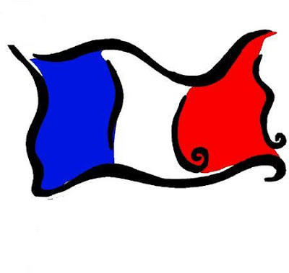



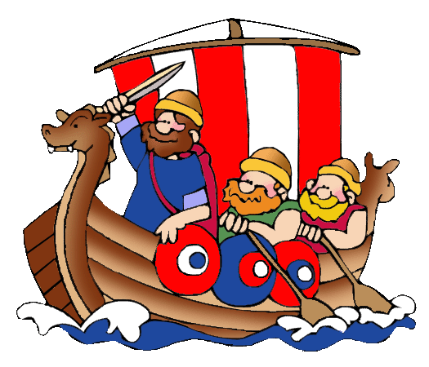
Topic (History): We will be learning all about Vikings. The children will be learning all about daily life, armour and weapons and Longships as well as receiving a visit from a very special guest.
DT: We will be creating our own Viking rune holders. The children will be following the design, make and evaluate process.
P.E: Our sports coaching will begin again this half term with Reds in the Community. The children will be learning how to play Tri-golf. The children will also be attending weekly swimming sessions on a Friday.
Science: Our topic this half term is sounds. The children will be learning all about the source of sound, how it’s made, vibrations, volume and pitch. They will also experiment with different instruments and investigating how the sound reaches their ears.
English: We will be looking at stories with dilemmas. We will be studying the Viking story The Saga of Biorn. The children will be looking at setting description and creating a storyboard using fronted adverbials as well as lots of work on spellings, punctuation and grammar. The children will also be writing a newspaper report on the Lindisfarne Raid.

Computing: this term year 4 will be starting to create a weather presentation.
Maths: The children will be carrying on their work with multiplication and division, learning the formal written methods. They will also be learning about area and starting to look at fractions.

