Spring 2 2019 Year 4
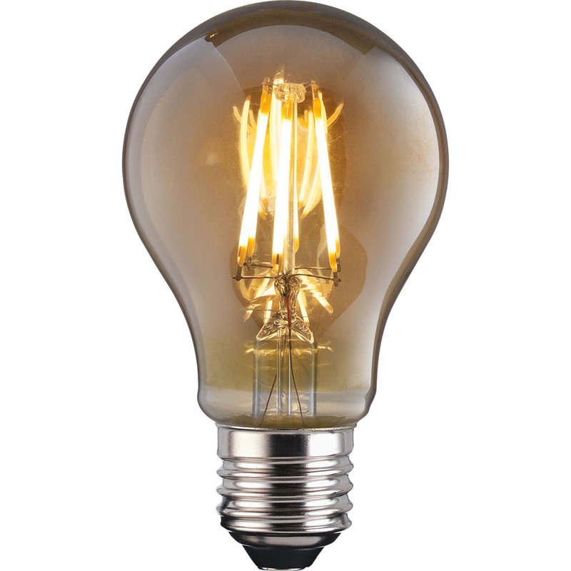
Newsletter

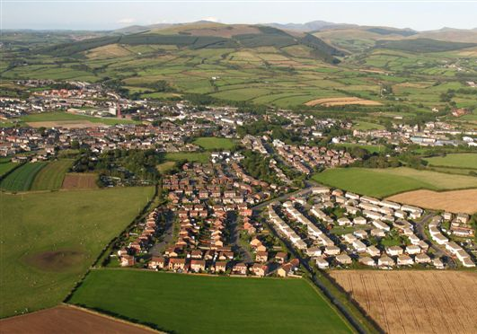
Topic (Geography): This half term is all about local Geography. The children will be learning all about the local area, including Egremont during WW1 and the local environment has changed over the years.
Art: Children are concentrating on drawing and sketching this half term and will be creating their own landscapes.
P.E: Our sports coaching will begin again this half term with Reds in the Community. The children will be learning how to play Netball and Natalie will be taking their Dance lessons. The children will also be continuing to attend their weekly swimming sessions on a Friday.
Science: Our topic this half term is electricity. The children will be identifying common appliances that run on electricity. They will also be constructing a simple series circuit, identifying and naming its basic parts, including cells, wires, bulbs, switches and buzzers. They will be able to recognise some common conductors and insulators too.
English: We will be looking at Playscripts this half term and we will be using Fantastic Mr Fox as our starting point. We will also be writing a persuasive text and an explanation text. The children will also be learning about apostrophes in their SPAG lessons.

R.E: This half term we are looking at Christianity. We will be learning all about Easter and why it is important to Christians.
Maths: The children will be continuing to look at fractions including adding them, comparing equivalents and then moving on to Decimals. The children will also be continuing to look at problem solving too.

French: The children will be learning about the weather and seasons.


Computing: This half term year 4 will be continuing their weather presentation.

