Summer 1 2019 Year 4
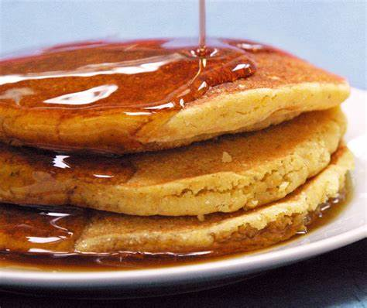
Newsletter

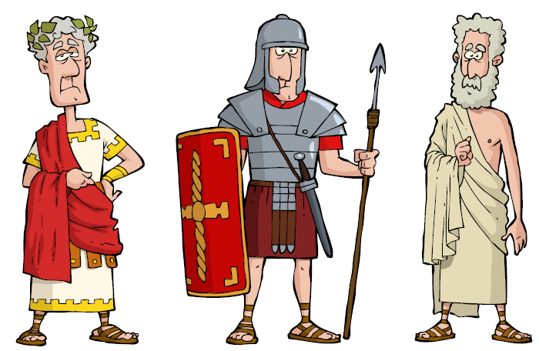
P.E: Our sports coaching will begin again this half term with Reds in the Community. Hanley will be teaching the children how to play Tennis. The children will also be learning how to play Rugby with our fantastic new coach Marnie.
Topic (Geography): This half term is all about local Geography. The children will be learning all about the local area, including Egremont during WW1 and the local environment has changed over the years.
DT: The children will be making food products in design and technology this half term, making wheat pancakes with dates and honey.
Science: This half term year 4 are looking at states of matter. They will be taking a close look at the difference between solids, liquids and gases and discovering how they can change state. We also have our science week at the beginning of half term and the children will spend the day experimenting on Thursday.
English: We are looking at diary entries and biographies this half term and the children will have a go at writing their own. In our SPAG lessons we will be learning how to punctuate direct speech and how to use commas and connectives effectively.

R.E: We are learning all about Judaism and how Jews show commitment to God.
Maths: We will continue to learn about decimals and will then be moving onto time and statistics. We are also continuing to work hard with our problem solving skills and improving our times table knowledge.

French: The children will be learning about countries, cities and towns in French.
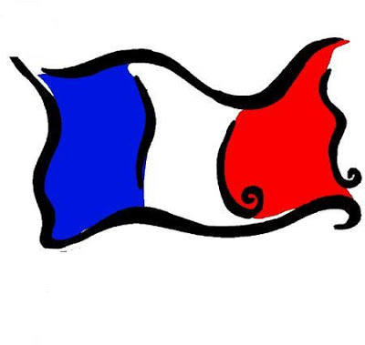

Computing: This half term year 4 will be designing and creating their own game using purple mash.

