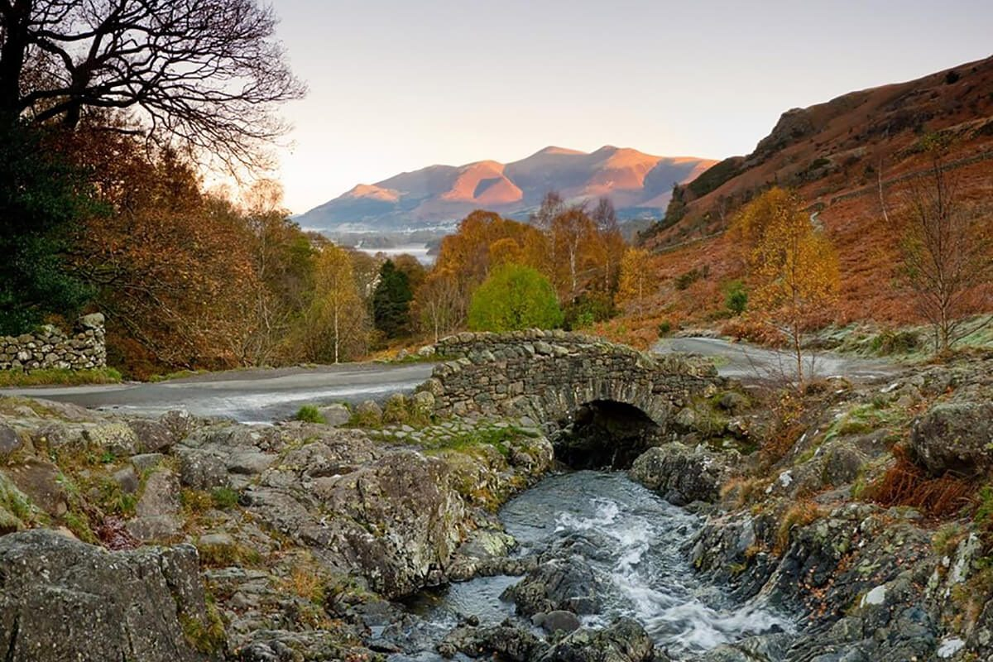
Summer 2 2019 Year 4
Newsletter

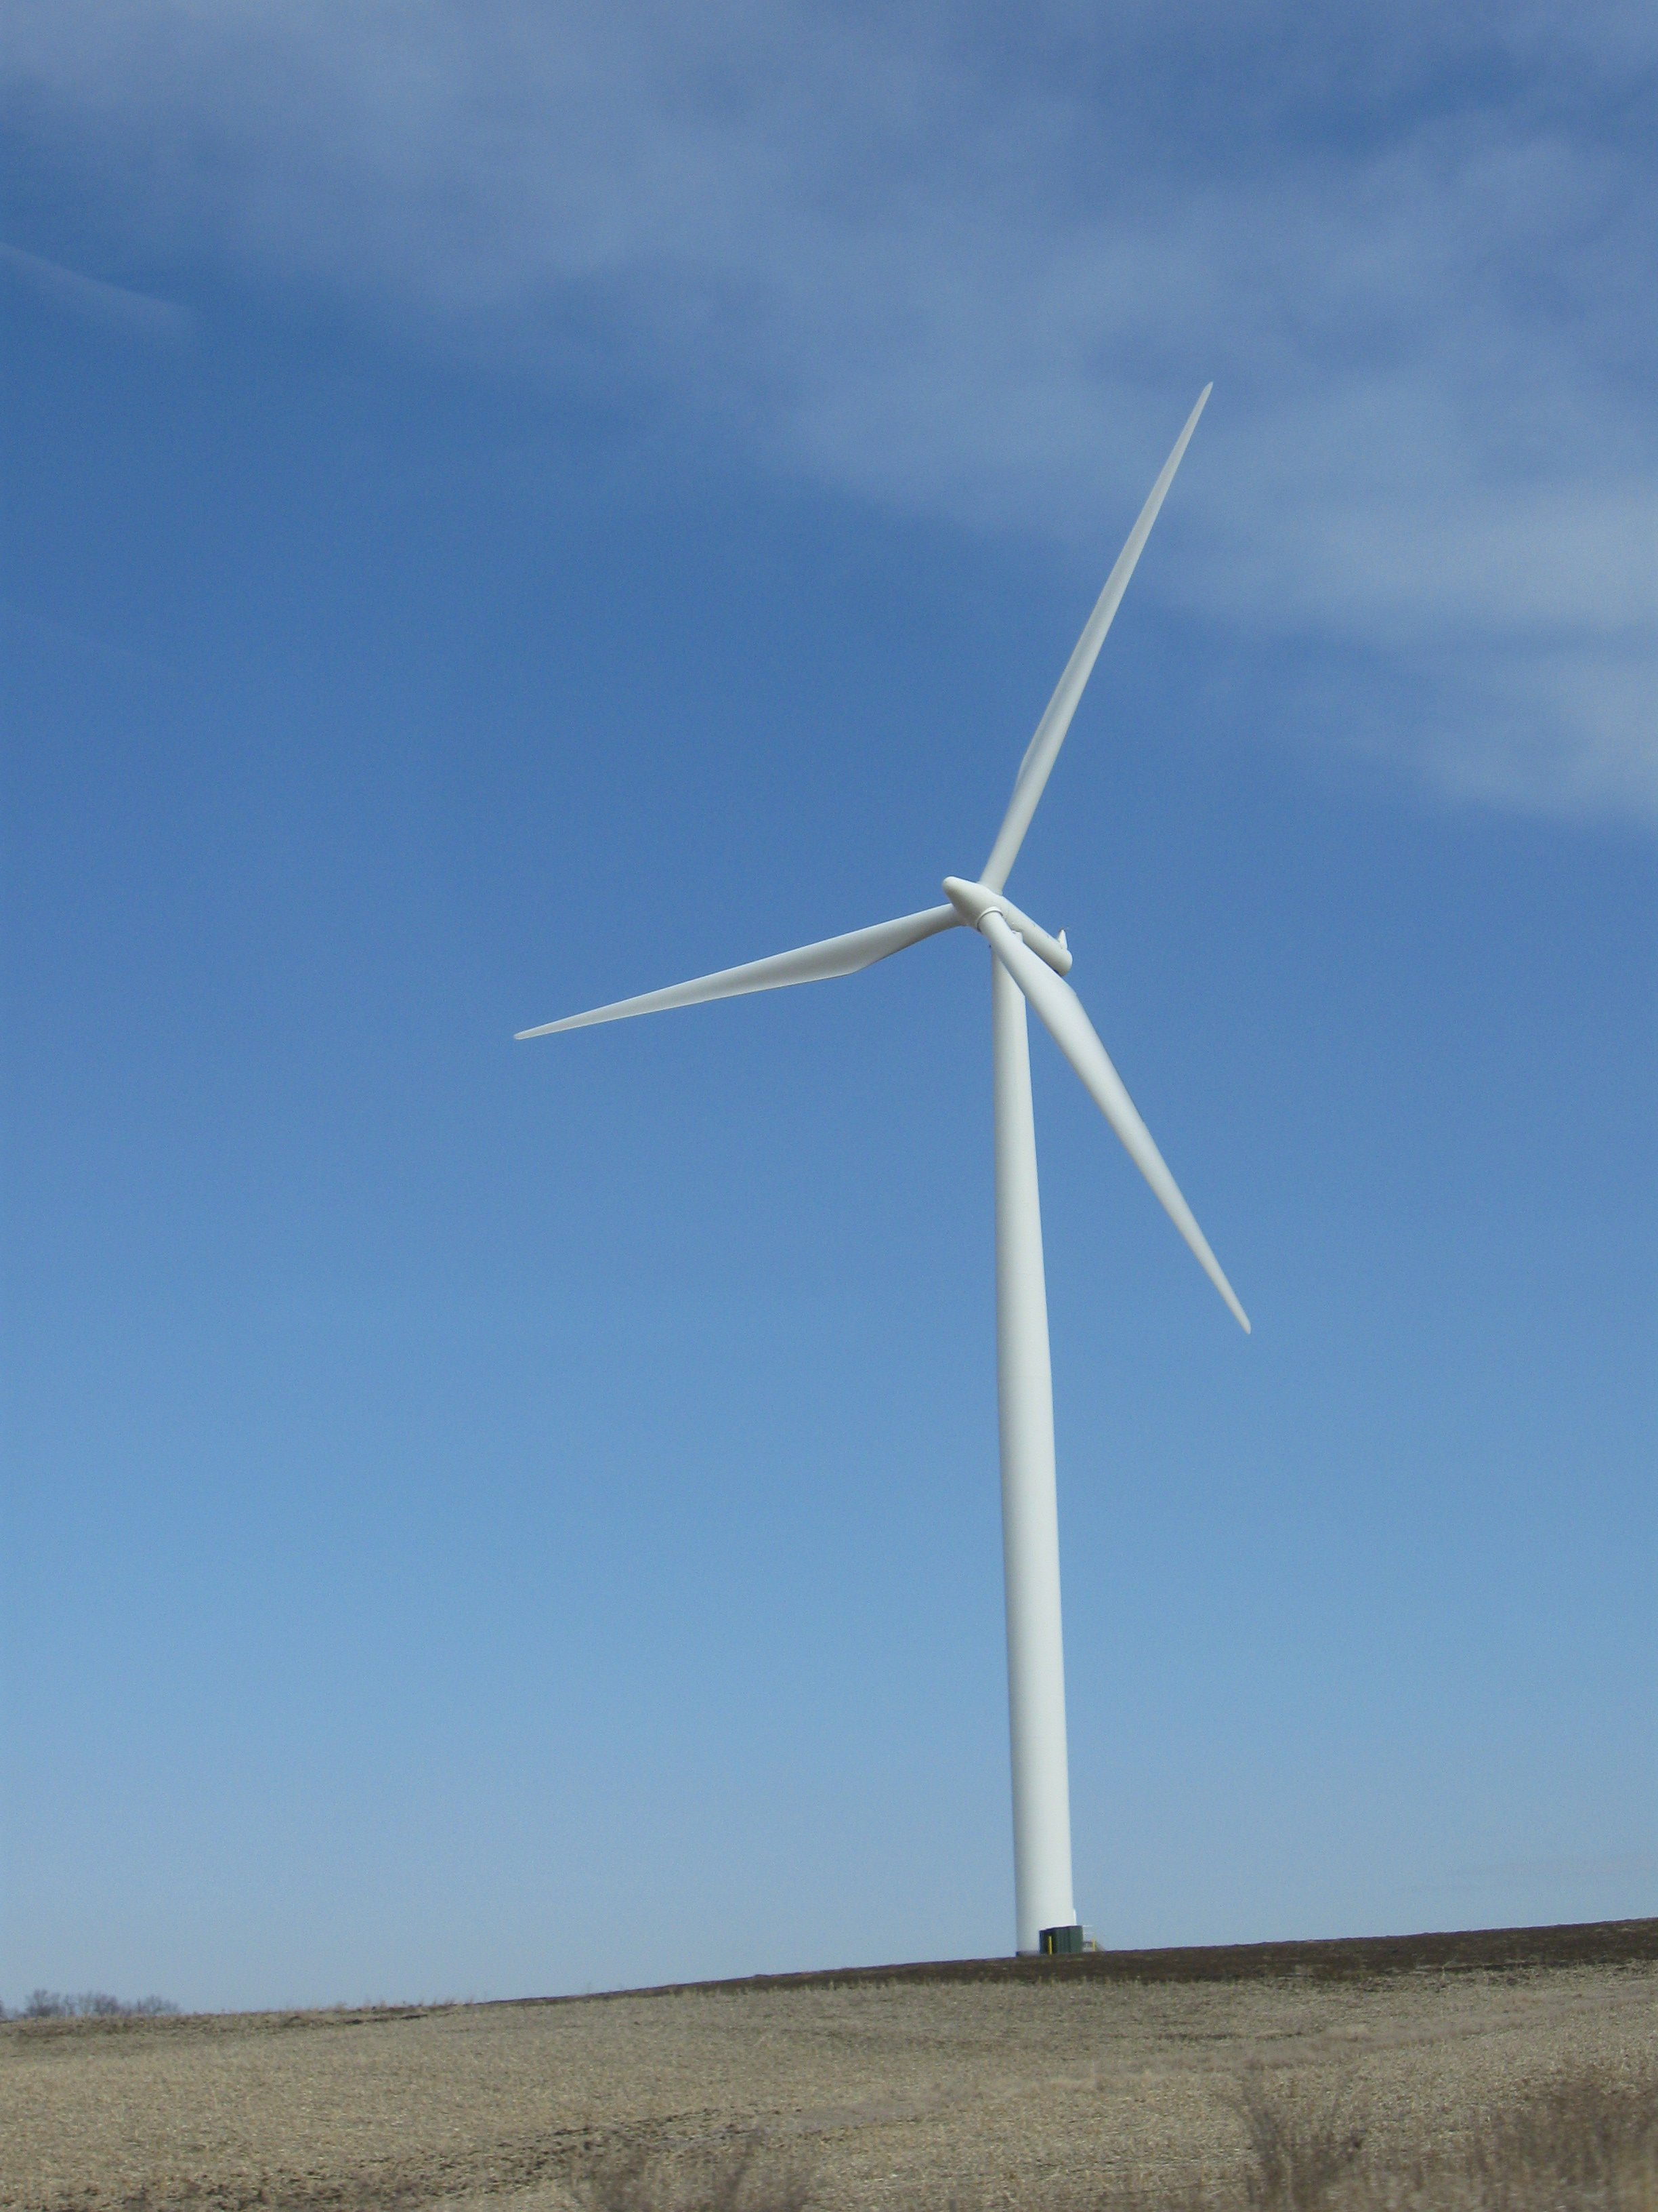
Topic (Geography): This half term is all about sustainability and how we can use renewable energy to reduce our carbon footprints.
Art: The children will be learning to paint of different surfaces and choosing different brushes to suit the purpose of their work. They will have a go at painting in the style of Georgia O’Keefe.
P.E: Our sports coaching will begin again this half term with Reds in the Community. Hanley will be teaching the children how to play rounder’s and cricket. The children will also be taking part in weekly athletics sessions with Natalie.
Science: We will be looking at the water cycle to conclude our states of matter topic and then our final topic of the year is ‘The Big Build’. We will be constructing towers and bridges and looking at how different animals build their homes too.
English: We are looking at poetry. We will be exploring Haiku and Tanka poems including writing our own versions. We also have our Wallace’s weird inventions challenge and we will be writing a recount about our school trip.
In our SPAG lessons we will be looking at different spelling rules.

R.E: We are learning all about Buddhism and what it means to lead a ‘good’ life.
Maths: We will continue to learn about statistics including line graphs and then we will be moving onto geometry. We are also continuing to work hard with our problem solving skills and improving our times table knowledge.

French: The children will be learning about countries, cities and towns in French.
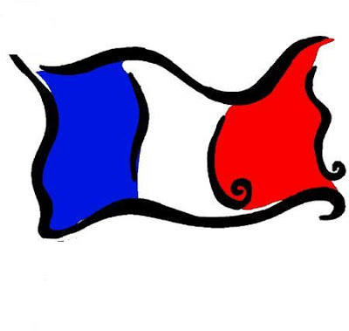

Computing: This half term year 4 will be continuing to create their own game using purple mash.

